1983.0646 Mining Hoist

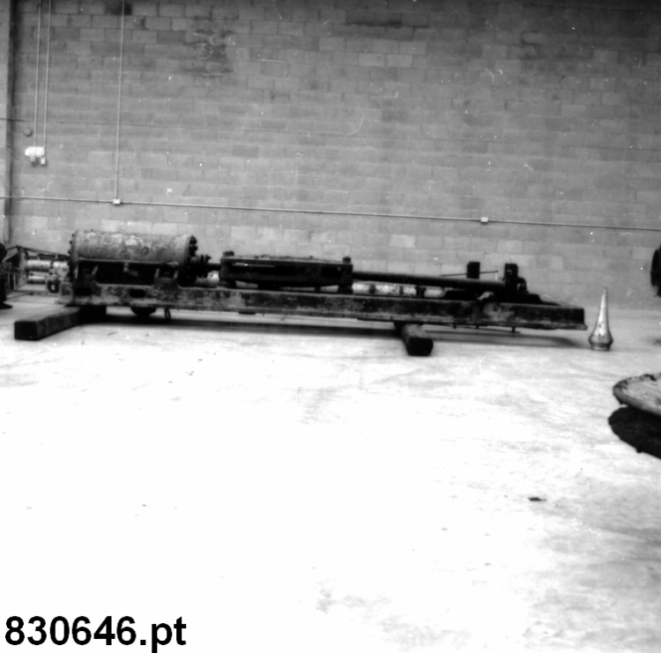

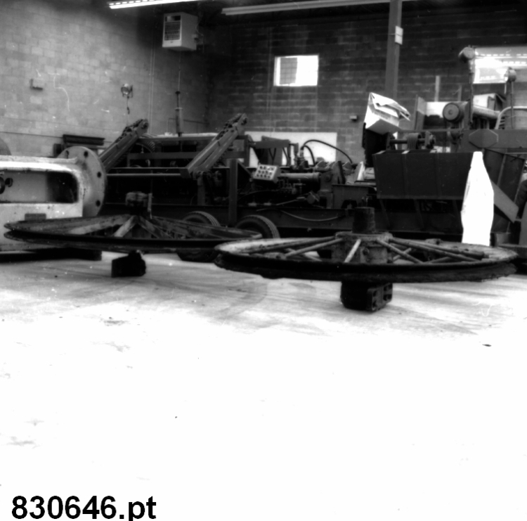

According to the original acquisition form, the piece of equipment was built probably circa 1890 by I. Matheson & Co. Limited of New Glasgow, Nova Scotia.

This piece of equipment is a major part of mining as it serves to bring miners and equipment up and down the shaft and to bring the ore to the surface for treatment. Even today, for underground mines, hoists are the most visible part of the mining operations.

Parts of a mining hoist

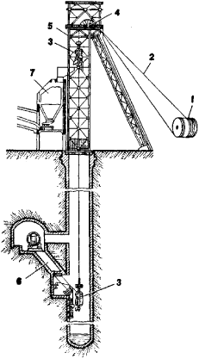

(1) hoisting machine, (2) hoist cables, (3) skips, (4) sheaves, (5) headframe, (6) loading chute, (7) bin

Parts of a hoisting machine

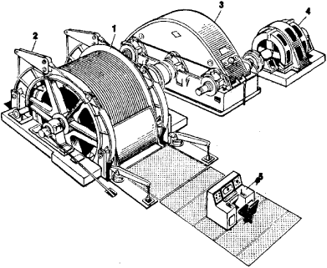

(1) winding drum, (2) brake, (3) reduction gears, (4) electric motor, (5) control console

